**TITLE OF PROJECT REPORT:**

**DOBSONIAN TELESCOPE**

**A REPORT ON PROJECT BASED LEARNING**

**(SEMESTER -II)**

*Submitted by*

**NAME OF THE CANDIDATE(S)**

**Aryan Agrawal**

**Jidnyesh Patil**

**Rohan Kamble**

**Ishan Rupwate**

**Neha Rathod**



**FIRST YEAR ENGINEERING**

**Society for Computer Technology and Research’s**

**PUNE INSTITUTE OF COMPUTER TECHNOLOGY**

**DHANKAWADI, PUNE – 43**

**A.Y. 2020-21**

**- CERTIFICATE -**

This is to certify that the work incorporated in the report entitled “**Dobsonian Telescope**,” is carried out by Mr./Ms.(Surname- First name- Middle name)________________ (Roll No.(five digits) ) ,who is part a group of students with Project Id ________ under the subject **Project Based Learning** during A.Y. **2020-2021**.

Such material has not been submitted to any other University/ Institute for any financial support. The literature related to the problem investigated has been appropriately cited and duly acknowledged wherever facilities and suggestions have been availed of.

**Date: Name & Sign of Project Guide**

**Place:** PUNE

**Name & Sign of PBL Coordinator Name & Sign of Head of Department**

**Prof.N. P. Sapkal Prof. E. M. Reddy**

**ABSTRACT**

Human space exploration helps to address fundamental questions about our place in the Universe and the history of our solar system. Through addressing the challenges related to human space exploration we expand technology, create new industries, and help to foster a peaceful connection with other nations.

The Dobsonian Telescope has brought the wonder, beauty and mysteries of the universe to Earth, spinning pictures out of light that have transformed our understanding of the universe.

Dobsonian telescopes are incredibly good and are great for amateurs and professional astronomers alike. They are also very economical compared to other telescopes. It opened a new portal to space exploration and astronomy.

Thus we decided to pick up this topic and with a fair amount of research, we have made this report on Dobsonian Telescope

**ACKNOWLEDGEMENT**

We express our gratitude to **First Year HOD Prof. E. M. Reddy** for providing this wonderful opportunity to help others with our knowledge by drafting this project.

We thank our subject teacher **Hrushikesh Khatri** for his inspiration and timely guidance which we recieved every week.

We would also like to thank our seniors for their constant support and guidance.

-Aryan Agrawal

-Jidnyesh Patil

-Rohan Kamble

-Ishan Rupwate

-Neha Rathod

**TABLE OF CONTENT**

| **Chapter No.** | **Title** | **Page no.** |
| --- | --- | --- |
| 1. | Analysis role of each component of telescope | 7-10 |
| 2. | Complementry parts which can be used instead of default components | 11-15 |
| 3. | What is magnification and how can we expand range of telescope | 16-18 |
| 4. | Explanation of Ray Diagram of Telescope | 19-21 |
| 5. | Formula of Resolution and Range of telescope and applying it on telescope | 22-27 |

**LIST OF FIGURES**

| **Figure No.** | **Figure** | **Page no.** |
| --- | --- | --- |
| 1. | Dobsonian Telescope | 7 |
| 2. | Dobsonian Telescope Assembly | 8 |
| 3. | Tube Cradle | 12 |
| 4. | Simple Box Cradle | 13 |
| 5. | Adjustable Box Cradle | 14 |
| 6. | Rocker Box | 15 |
| 7. | Ground Board | 15 |
| 8. | Magnification Formulas | 16 |
| 9. | Magnification Using Barlow Lens And Extension Tube | 18 |
| 10. | Dobsonian Telescope Ray Diagram | 19 |
| 11. | Dobsonian Telescope Polar Alignment | 20 |
| 12. | Airy’s Disc | 22 |
| 13. | Resolving Limit | 24 |
| 14. | Magnification Formula | 25 |
| 15. | Magnification Example 1 | 26 |
| 16. | Magnification Example 2 | 26 |
| 17. | Moon taken with phone through 10" Dobsonian Telescope | 27 |

**REPORT : DOBSONIAN TELESCOPE**

**Chapter 1**

**Analysis role of each component of telescope:**

A **Dobsonian telescope** is an altazimuth-mounted Newtonian telescope design popularized by John Dobson in 1965 and credited with vastly increasing the size of telescopes available to amateur astronomers. Dobson's telescopes featured a simplified mechanical design that was easy to manufacture from readily available components to create a large, portable, low-cost telescope. The design is optimized for observing faint, deep-sky objects such as nebulae and galaxies. This type of observation requires a large objective diameter (i.e., light-gathering power) of relatively short focal length and portability for travel to less light-polluted locations.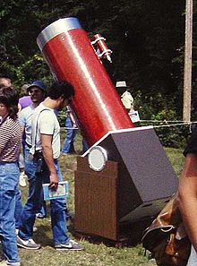

Dobsonians are intended to be what is commonly called a "light bucket"operating at low magnification, and therefore the design omits features found in other amateur telescopes such as equatorial tracking. Dobsonians are popular in the amateur telescope making community, where the design was pioneered and continues to evolve. A number of commercial telescope makers also sell telescopes based on this design. The term *Dobsonian* is currently used for a range of large-aperture Newtonian reflectors that use some of the basic Dobsonian design characteristics, regardless of the materials from which they are constructed.

It is hard to classify the Dobsonian Telescope as a single invention. In the field of amateur telescope making most, if not all, of its design features had been used before.John Dobson, credited as having invented this design in 1965 pointed out that "for hundreds of years, wars were fought using cannon on "'Dobsonian' mounts". Dobson identified the characteristic features of the design as lightweight objective mirrors made of porthole glass, and mountings constructed from plywood, Teflon strips and other 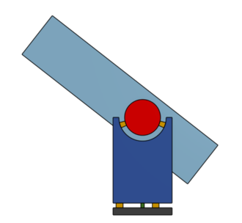

low-cost materials. Since he built these telescopes as aids in his avocation of instructional sidewalk astronomy, he preferred to call the design a "sidewalk telescope".Dobson combined all these innovations in a design focused towards one goal: building a very large, inexpensive, easy to use, portable telescope, one that could bring deep-sky astronomy to the masses.

From its inception, telescope makers have been modifying the Dobsonian design to fit their needs. The original design fit the needs and available supplies of one person—John Dobson. Other people devised variants that fit their own needs, abilities, and access to parts. This has led to significant diversity in "Dobsonian" design.

**Collapsible tube assemblies**

“Classic” design tube assemblies would require a large van for transport. Designers started coming up with disassembleable or collapsible variants that could be brought to the site with a small SUV, hatchback, or even a sedan. This innovation allowed the amateur astronomy community access to even larger apertures.

**The truss tube**

Many designs have combined the advantages of a light truss tube and a collapsible design. Collapsible "truss tube" Dobsonians appeared in the amateur telescope making community as early as 1982 and allow the optical tube assembly, the largest component, to be broken down. As the name implies, the "tube" of this design is actually composed of an upper 'cage assembly', which contains the secondary mirror, and focuser, held in place by several rigid poles over a ‘mirror box’ which contains the objective mirror. The poles are held in place by quick-disconnecting clamps which allow the entire telescope to be easily broken down into its smaller components, facilitating their transport by vehicle or other means to an observing site. These truss tube designs are sometimes incorrectly called a [*Serrurier truss*](https://en.wikipedia.org/wiki/Serrurier_truss), but since the main truss is not built with an opposing mirror cell truss it only performs one function of that design, i.e., keeping the optics parallel.

**Modifications to the altazimuth mount (rocker box)**

The main attribute of a Dobsonian's mount is that it resembles a "gun carriage" configuration with a "rocker box" consisting of a horizontal [trunnion](https://en.wikipedia.org/wiki/Trunnion) style altitude axis and a broadly supported azimuth axis, both making use of material such as plastic, Formica, and Teflon to achieve smooth operation. Many derivative mount designs have kept this basic form while heavily modifying the materials and configuration.

**Compact “rocker box” mount**

Many designs have increased portability by shrinking the altazimuth (rocker box) mount down to a small rotating platform. The altitude trunnion style bearing in these designs becomes a large radius roughly equal to or greater than the radius of the objective mirror, attached to or integrated into the tube assembly which lowers the overall profile of the mount. The advantage of this is that it reduces the total telescope weight, and the telescope's balance becomes less sensitive to changes in the weight loading of telescope tube from the use of heavier eyepieces or the addition of cameras etc.

**Overcoming the limitations of the altazimuth mount**

Since the late 1990s many innovations in mount design and electronics by amateur telescope makers and commercial manufacturers have allowed users to overcome some of the limitations of the Dobsonian style altazimuth mount

1. **Digital setting circles**: The invention of microprocessor-based digital setting circles has allowed any altazimuth mounted telescope to be fitted or retrofitted with the ability to accurately display the coordinates of the telescope direction. These systems not only give the user a digital read-out for right ascension (RA) and declination (dec.), they also interface with digital devices such as laptop computers, tablet computers, and smartphones using live ephemeris calculating / charting planetarium software to give a current graphical representation of where the telescope is pointing, allowing the user to quickly find an object.
2. **Equatorial platform**: The use of equatorial platforms (such as the Poncet Platform) fitted under the altazimuth mount has given users limited equatorial tracking for visual and astrophotographic work. Such platforms can incorporate a clock drive for ease of tracking, and with careful polar alignment sub-arc second precision CCD imaging is entirely possible. Roeser Observatory, Luxembourg (MPC observatory code 163) have contributed hundreds of astrometric measurements to the Minor Planet Center using a home-built 20" dobsonian on an equatorial platform.

**Chapter 2**

**Complementary parts which can be used instead of default components :**

In this section we will show you how to build a Dobsonian Mount for a small (12 inches or less primary mirror) Newtonian optical tube. You can use this mount with an existing Newtonian, or perhaps you have just built the Newtonian.

While our plans will be as specific as possible, by necessity they must be scaled or your tube diameter and length. We will therefore provide many dimensions as formulas with the specificity of your tube as variables; you will have to do some simple adding or multiplying to determine dimensions. Do not try to build this mount without a completed and functional Newtonian telescope in hand; critical dimensions such as the tube length below the balance point of the tube are almost impossible to calculate without the actual tube and accessories, such as eyepieces and finder scopes, in place on the tube.

While houses may be built from the ground up, we will build from the tube down. The diameter and length of the tube determine many dimensions, so calculating clearances from the tube outwards to the rest of the mount is the best strategy. Whenever possible, we will strive to use much easier to make straight cuts, and only use curved parts when absolutely necessary.

Our main material for the mount is plywood. We will also use standard hardware, such as screws, exposed items (screws, which will be painted or sealed with the plywood after assembly is not nearly as critical to be rustproof). We will also use a few more specialized items for bearings (Teflon pads and textured laminate) and will provide details on where to buy these items at the appropriate time.

**-- Tube Cradle :**

The cradle adapts the tube to the mount – it firmly holds the round tube and provides flat, square surfaces to attach the altitude bearings to the side. Often a handle is attached to the top of the cradle to make carrying the tube and cradle more convenient. A cradle must be sized to the snuggly fit the outside diameter of your telescope tube.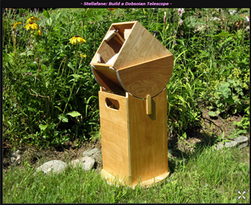

**-- Cradle Length :**

The length of the cradle (length along the tube) should scale with the size of the telescope. A good rule of thumb is to make the cradle about twice the diameter of the primary mirror. This makes a 6 inch scope cradle one foot long and an 8 inch scope cradle 16 inches long. For 10 inch mirrors and above, this rule may make the cradles a bit too long. You want the cradle to be long enough to attach your altitude bearings, so you might want to read ahead, figure out the altitude bearing diameter you will use, and scale the cradle to them (remember that the altitude bearings will be attached at an angle, so the cradle length can be somewhat smaller than the bearing diameter). This is not a critical dimension, you can certainly adjust it to your taste.

**-- A Simple Box Cradle :**

The simplest cradle to build is a box cradle. Consisting of four pieces of plywood sized to snuggly fit the outside diameter of your tube, it is glued and screwed together at the 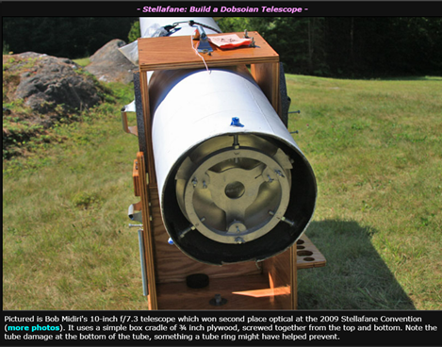

edges. Some versions use ¾ x ¾ inch lengths of wood on the inside corners of the box to reinforce the joints; you can screw the box together on the inside for the top and sizes to hide the screw heads (and from the bottom on bottom side, which is not very visible).

While simple to make, a box cradle does not allow for adjustment for the tube within the cradle. This means that the angle of the eyepiece is fixed (usually set at about a 45 degree angle) and balance of the tube in the cradle cannot be easily adjusted. With very little additional work, we can build an adjustable cradle, which is the cradle we will build.

**-- Build an Adjustable Tube Cradle :**

The primary advantages of an adjustable cradle are :

· Eyepiece angle can be easily adjusted, Most people like it pointing almost straight up for viewing near the zenith, with intermediate positions used for viewing in between.

· Tube balance can be easily adjusted. This is advantageous if some of your eyepieces or optional accessories (like a camera adaptor) are heavy.

· The tube can be easily removed from the cradle if necessary.

In our adjustable cradle, we will add eight 45 degree corner braces to the box cradle; they will be sized so that the tube rests on and is squeezed by them, not the sides of the box. The lower four are fixed; the upper four have adjustable pressure on them, so they can be loosened to adjust the tube and tightened to hold the tube firmly in place. The additional work needed to do this is small, and the fixed braces stiffen the box as an added benefit. All this is done with simple straight cuts that are easy to make.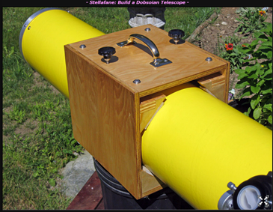

We will use a mixture of ½ and ¾ inch plywood in our cradle to keep the weight down. We realize this might not be the most economical way to build this; if you buy a single sheet of ¾ inch plywood you may have enough material to build the entire mount – so feel free to use ¾ inch everywhere, adjusting the dimensions as necessary.

**-- Altitude Bearing :**

A Dobsonian Mount is a version of an “Alt-Az” (Altitude-Azimuth) mount. Hence the bearings that allow the telescope to aim in altitude are the altitude bearings. Many people also call these the side bearings, as they are located on either side of the tube, attached to the cradle on small Donsonians or to the mirror box on larger, truss tube Dobsonians.

**-- Finding the balance point :**

Insert your tube into your cradle, taking a guess at where it will balance. Then put your heaviest eyepiece in the focuser, and make sure all tube mounted accessories like finders are on the tube. We want the top of the tube to be in its heaviest configuration, because that will cause the back of the tube to sick out the farthest to achieve balance.

**-- The Rocker Box :**

The Rocker Box is a major structural component of a Dobsonian Mount. On the top side, it supports the Teflon pads for the Altitude Bearings, and on its bottom side, it has laminate and a pivot bolt hole for the Azimuth Bearing. In between, we try to build a light yet rigid box structure to connect it all together. While there are a number of minor parts to the rocker box assembly, the four major parts are two sides, one front and a bottom.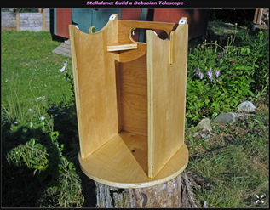

**-- Ground Board and Final Assembly :**

The Ground Board is a simple piece of plywood that hold the feet, azimuth bearing pads and pivot in place. Because the pads are place directly over the feet, there is essentially no vertical load on this part; it only has some small loading in holding the parts in place horizontally.

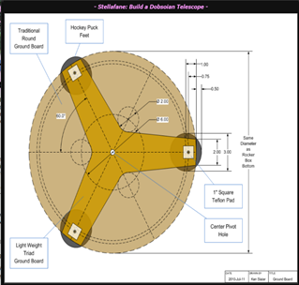

Therefore it can be made ½ inch plywood and have quite a bit of wood removed, as in our triad design without failing. You can choose to make the traditional circular ground board if you wish, and you can use ¾ inch plywood for either design.

**Chapter 3**

**What is magnification :**

There are several important factors to consider with telescope magnification: magnification, true field, apparent field, exit pupil, and resolution.

The first of these is telescope magnification, and by this I mean angular magnification. We see the universe in terms of angles. A 50-power telescope will make the ½° disk of the Moon appear 25° wide.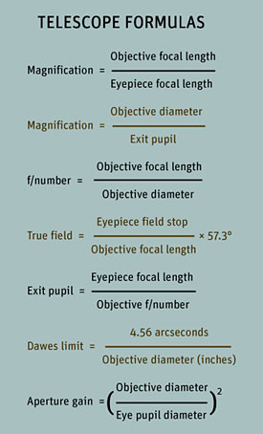

To achieve low telescope magnification, use long-focal-length eyepieces. Telecompressor lenses can shorten the effective focal length of some telescopes, lowering the magnification of a given eyepiece used with that telescope. High telescope magnifications can be obtained by using short-focal-length eyepieces.

Barlow lenses (which can even be "stacked") allow a short-focal-length telescope to achieve absurdly high magnifications. But beware: these high magnifications may not be what we want! The 600-power, 2.4-inch "department store" telescope is a prime example of a malicious turn-off to budding amateur astronomers — the resulting field at that high magnification is too small, too dim, too fuzzy, and too shaky to be of much use.

While an eyepiece's focal length determines the optical system's magnification, the **f/number** is of little importance visually. A "fast" telescope implies a short focal length and a large field. Fast, however, is a term borrowed from photography (an f/5 telescope can take a photograph with one-fourth the exposure time of an f/10 instrument).

Visually, well-made fast and slow telescopes of the same aperture have no difference in image brightness or resolution. I find that photographers have the most difficulty understanding this concept, because their experience that a faster f/number means brighter images on film and in the viewfinder is so ingrained.

**Expanding range of Telescope :**

1. **Using Barlow Lens :**

There is another technique with which you can increase the magnification of your telescope even further. You can do that by inserting a Barlow lens in front of the eyepiece. A Barlow lens is a diverging lens, that is to say, this type of lens causes light rays to spread out. When used in a telescope, a Barlow lens increases the telescope's focal length, thus, magnifying the image.

Barlow lenses are usually placed before the eyepiece, and they may double or triple the magnification of a telescope. Barlow lenses are usually classified as 2x and 3x, meaning they increase the original magnification of a telescope by two or three times, although other magnifications exist.

By placing a Barlow lens before the 25mm eyepiece of the 70mm telescope, will double the magnification of the eyepiece. If the magnification without the Barlow lens was 28x, using the Barlow will be 56x. Whereas when placing the Barlow lens in front of the 9mm eyepiece, the magnification will increase to 155x. Thus in these two examples.

The magnification is doubled. There are other Barlow lenses with higher magnifications.

The same is true for a Barlow lens grated 3x. In this case, the magnification of a telescope will be tripled, depending on the eyepiece used. With the 25mm eyepiece, the magnification will triple to 84x, whereas with the 9mm eyepiece the magnification will triple to 233x.

1. **Using Extension Tube :**

The magnification of a telescope may be increased even further by adding an extension tube between the Barlow lens and the eyepiece. You can buy a 1 inch PVC tube and sand it a little on one end. It will fit perfectly on the Barlow barrel. On the other end, you can cut and attach a piece of the same tube to serve as a holder for the eyepiece. This is what I did with the extension tube on the picture.

By placing an extension tube between the Barlow lens and the eyepiece, you will increase the magnification of a telescope by two three or more times, depending on the size of the extension tube. The idea is that as you increase the distance between the Barlow lens and the eyepiece, you reduce the eyepiece's focal length, thus increasing the magnification of the telescope.

1. **Using the Barlow Lens Plus an Extension Tube :**

The image seen through the telescope on the left with the Barlow lens and the 25mm eyepiece. On the right, the same image with the same optical devices mentioned before and an extension tube which quadruples the distance given by the Barlow lens.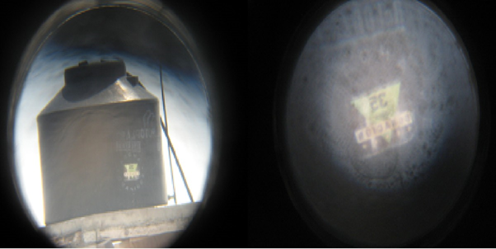

The image is that of a water tank on top of a house about two miles away. It would have been almost impossible to have distinguished the letters on the water reservoir without the aid of a telescope.

**Chapter 4**

**Ray diagram of Dobsonian telescope :**

Dobsonian telescope is a reflector telescope. In a reflecting telescope an image is formed by reflection from a curved mirror. Light from Object at infinity is incident on the objective mirror which is a concave mirror of large focal length and aperture. Light gets reflected and is incident on the secondary mirror (which is placed in the path just before the focus at an angle of 45˚of principle axis). The rays reflected from secondary mirror is incident on convex lens which is used as eyepiece. The final image is Magnified and upright.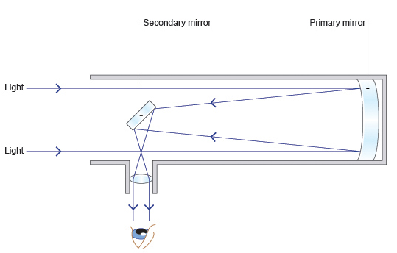

**Advantages of using Dobsonion Telescope :**

1. Price: It is way more cheaper as compared to other telescopes of same size

2. Good for Beginners and all ages: Amateur astronomers rate the likes of the Orion SkyQuest 6-inch as a good starting point for beginner astronomers wanting ‘the best bang for the buck’. Other brands include Saxon, Skywatcher, and Meade. It’s an economical buy. And, a 6-inch aperture in a Dobsonian means you should get useful views of the moon and planets. A focal length of 1200mm and aperture of 6″ are good for planet viewing.

3. No need to spend time on polar alignment,Polar alignment is the process of accurately aligning the polar axis of your mount with the north (or south) celestial pole. By aligning the axis of your telescope mount with the motion of the sky, you can accurately track objects in space.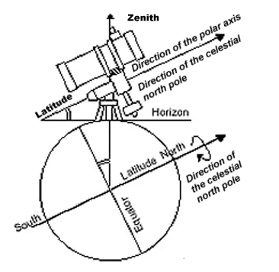

Fig :Polar alignment

4. Due to mount it is very stable as compared to the telescopes with tripod as it does not tend to shake when touched lightly.

**Disadvantages of Dobsonian telescope :**

1. From time to time, Dobsonians require collimation, which is the process of aligning the mirrors so that they work together to deliver well-focused light to your eyepiece.

2. They are not very compact which can make them difficult sometimes to transport and to set up.

3. Not good choice for astrophotography, which is photography of astronomical objects, celestial events, and areas of the night sky.

**Chapter 5**

**Formula of Resolution and Range of telescope and applying it on telescope :**

**What is the Diffraction Limit?**

When a point object is imaged using a circular opening (or aperture) like a lens or the iris of our eye, the image formed is not a point but a diffraction pattern. This is true, particularly when the size of the object is comparable to the wavelength of light.

Just as in [single slit diffraction](https://byjus.com/physics/single-slit-diffraction/), a circular aperture produces a diffraction pattern of concentric rings that grow fainter as we move away from the center. These are known as **Airy’s discs**.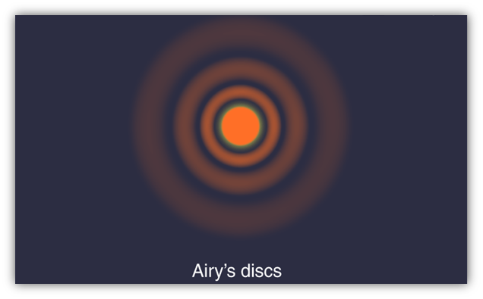

Because of this point sources close to one another can overlap and produce a blurred image. The half-angle θ subtended by the first minimum at the source is given by the relation: **sinθ ≈ 1.22 λ/d**

To obtain a good image, point sources must be *resolved* i.e., the point sources must be imaged such that their images are sufficiently far apart that their diffraction patterns do not overlap. For this, the minimum distance between images must be such that the central maximum of the first image lies on the first minimum of the second and vice versa. Such an image is said to be just resolved. This is the famous Rayleigh criterion.

The criterion is given by the above formula as:- **sin θR ≈ △θ ≈ 1.22 λ/d**

**What is the resolving limit of a telescope ?**

The smallest separation between two point objects at which they appear just separated is called the limit of resolution of an telescope.

Formula of Limit of resolution is,

△θ =1.22 λ

D

Here,Λ (lambda) = wavelength of the light

D = diameter of the lens / mirror

△θ = angular separation between the objects

This is the minimum angle required between two objects to clearly distinguish between them.

· If the angle between objects is less than △θ then the objects will appear to be one and will be hard to distinguish.

· If the angle between the objects is more than △θ then the two objects will be clearly distinguishable.



Here , the fully resolved image is visible when the angular separation

Is greater. And when it is lesser the image is unresolved

**What is the resolution of a telescope?**

The angular resolving power (or **resolution) of a telescope** is the smallest angle between close objects that can be seen clearly to be separate. **Resolution** is limited by the wave nature of light.

**It is the reciprocal of Resolving Limit.**

The **resolution** of the telescope is given by,

**R = 1 = D**

**△θ** **1.22 λ**

Where, D is the diameter of the aperture of the telescope.

**Range of Telescope (Magnification):-**

The amount that a telescope enlarges its subject.

It's equal to the **telescope's focal length** divided by the **eyepiece's** **focal length**.

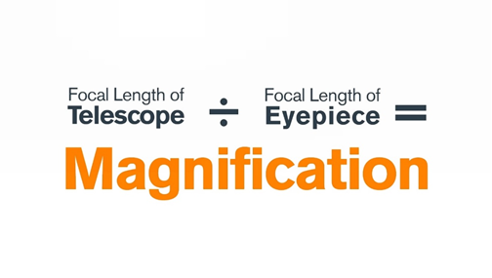

**Calculating magnification of the telescope :-**

We’ll calculate the magnification of INSPIRE 80AZ REFRACTOR TELESCOPE

First we’ll check the focal length of the telescope, which will be given on it.

Focal length of the telescope is 900 mm.

Then we’ll check the focal length of eyepiece.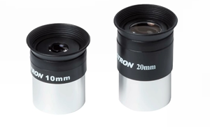

In this case we have two eyepieces.

* **10 mm**·
* **20 mm**

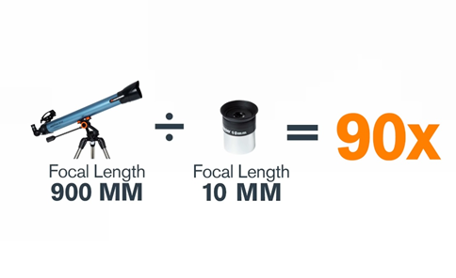

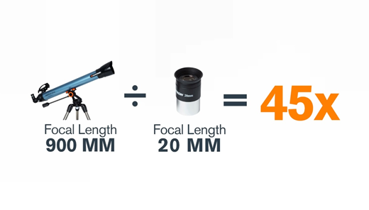

## 

## 

## 

## **What Can You See with Dobsonian Telescopes?**

#### **Near Space Objects – The Moon, Planets, The Sun**

Thanks to the ease of the Alt-Azimuth mount and the wide field of view (FOV) generally provided by these models, they’re a perfect fit for amateur astronomers on a night of visual observing. We can twist and turn the scope to the Moon, to Mars, and the stars.

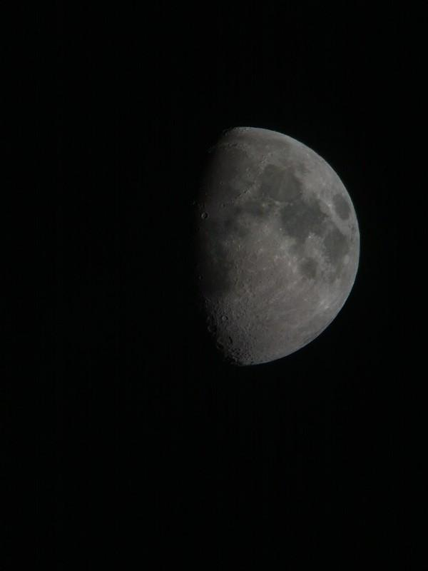

Img:Moon taken with phone through 10" Dobsonian Telescope at Mount Burnett Observatory

#### **Deep Space Objects (DSOs) – Galaxies, Nebulae, Clusters**

Dobs are equipped for viewing these further and fainter objects as well, although tracking these can be quite a challenge without a properly integrated system. In general, finding any object in the night sky shouldn’t take much effort at all for one of these.

**REFERENCE**

**[1]** [**www.nasa.gov**](http://www.nasa.gov)

**[2]** [**www.google.com**](http://www.google.com)

**[3]** [**www.skyandtelescope.org**](http://www.skyandtelescope.org)

**[4]** [**www.wikipedia.com**](http://www.wikipedia.com)

**[5]** [**www.quora.com**](http://www.quora.com)

**[6] Asteroid Hunters - Book by Carrie Nugent**

**[7]**[**https://www.phy.olemiss.edu/Astro/Telescope_Intro.pdf**](https://www.phy.olemiss.edu/Astro/Telescope_Intro.pdf)

**[8]**[**https://cosmicpursuits.com/1016/newtonian-reflectors-and-dobsonian-telescopes/**](https://cosmicpursuits.com/1016/newtonian-reflectors-and-dobsonian-telescopes/)

**[9]** [**https://telescopenights.com/dobsonian-telescope-advantages-and-disadvantages/**](https://telescopenights.com/dobsonian-telescope-advantages-and-disadvantages/)

**[10]**[**https://stellafane.org/tm/dob/index.html**](https://stellafane.org/tm/dob/index.html)

**[11]**[**https://byjus.com/physics/resolving-power-of-microscopes-and-telescopes/**](https://byjus.com/physics/resolving-power-of-microscopes-and-telescopes/)

**[12]**[**https://optcorp.com/blogs/telescopes-101/a-guide-to-dobsonian-telescopes**](https://optcorp.com/blogs/telescopes-101/a-guide-to-dobsonian-telescopes)